For Immediate Release

Living Proof: Drawing in 19th-Century Japan

November 3, 2017–March 3, 2018

Museum-wide exhibition examines practice and role of drawing in late Edo–early Meiji Japan; includes rare examples never before on public view.

Companion exhibition intersperses 20th-21st-century animated films among the 19th-century drawings
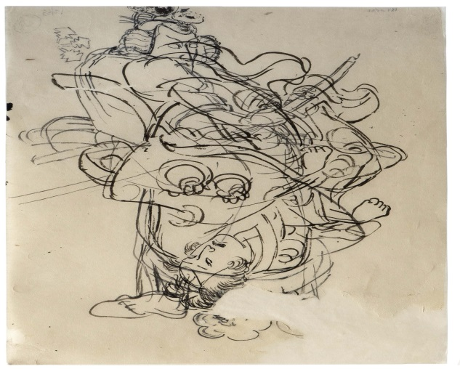
Utagawa Kuniyoshi, Study of Two Actors, 1830s-50s
ST. LOUIS, October 11, 2017— The Pulitzer Arts Foundation presents Living Proof: Drawing in 19th-Century Japan, an exhibition that will explore the methods, techniques, and subjects of drawings during Japan’s late Edo (1603–1868) and early Meiji (1868–1912) periods, highlighting some key practitioners, as well as the primary role of drawing as the first step in the process of creating ukiyo-e woodblock prints. In so doing, the exhibition will shed light on a body of work that, while compellingly expressive and frequently virtuoso in execution, was not treated as an independent art form at the time, lacking even a uniform terminology to describe it. With nearly eighty drawings, on loan from public and private collections nationwide, this is the first museum exhibition of its kind in over thirty years.

Living Proof has been organized by the Pulitzer and is co-curated by independent curator Kit Brooks and Pulitzer Associate Curator Tamara H. Schenkenberg. It is on view from November 3, 2017, through March 3, 2018.

In a small companion exhibition, three independent animated films from Japan will be interspersed among the exhibition’s nineteenth-century Japanese drawings, highlighting a continuum from drawings on paper to moving images. Titled Rough Cut: Independent Japanese Animation, this presentation has been curated by Pulitzer Arts Foundation Assistant Curator Stephanie Weissberg.

Tamara H. Schenkenberg states, “The drawings on view in Living Proof were largely conceived as one step on a pathway to a final product—a woodblock print—and were thus evanescent, created with the expectation of being destroyed. To view the works in this exhibition as “living proofs” is thus to celebrate their unlikely survival. At the same time, by highlighting the often-unseen improvisations, alterations, and even imperfections that have been excluded from histories of printmaking in Japan, Living Proof reframes these drawings as artworks in their own right, bearing witness to the artist’s creative role in this process.”

Background
In nineteenth-century Japan, the primary role of what we call drawing—including many of the works on view in the exhibition—was as a means of creating the ukiyo-e woodblock prints that have come to be indelibly associated with Japanese art of the period. Commercially produced for mass appeal, these were popular among economically rising members of the lower classes, who decorated their homes with prints that most frequently depicted images of city life, including scenes, such as kabuki theater or brothels, that were drawn from the entertainment districts.
Utagawa Kuniyoshi, Three Kabuki Actors, ca. 1850

These popular prints were collaboratively created by a team of artists, carvers, printers, and others with highly specialized skills, beginning with designs devised by artists in ink on mulberry paper. These would be altered, corrected, and expanded before the final versions were sent to a carver, who translated them into woodblocks. In the vast majority of cases, the artist’s original drafts would be discarded, if they had not already been destroyed by the carvers during the printmaking process.

But some of these drawings survived, works of a vitality and immediacy that ensure their standing as independent artworks. Moreover, not all drawings in this period were created as designs for prints. Some were intended to be copied by students, some as exercises in draftsmanship, and some for the artist’s own practice, serving a purpose that is today unknown. These too are included in the exhibition, where they represent process rather than perfection, opening a window onto the intimate interaction between artist and medium.

Exhibition
Living Proof begins with a selection of depictions of guardian figures—talismanic beings believed to have protective qualities—that give a sense of the energy and expressiveness that characterize the best of nineteenth-century Japanese drawings. In one work by an unidentified artist, the figure of Shōki, who stood in eaves and entryways to guard against evil spirits and disease, appears massive in scale, barely fitting on the page, with a face and beard that look almost electrically charged. Evident in this image is the way that artists of the era typically drew their imagery in black ink, with red used for corrections. Yet the red here also conveys a sense of movement that adds to the dynamism of the depiction, and one senses that the image would lose something in its translation into a print, where Shōki would be depicted in black alone.

This gallery also includes a selection of sketches by Katsushika Hokusai (1760–1849), perhaps the Japanese artist best known to Westerners, providing an introduction to the way he used drawing to continuously and rigorously develop his skill. An image of four sparrows in flight, for example, shows him working out the positions of their bodies with successive applications of grey, red, and black. Here, too, the red lines in the drawing give a sense of movement that would be lost in a print. Another example, this one depicting two oni—imp-like folkloric demons—is an image of playful contrast—one figure is coiled in apparent fear as the other springs to action—demonstrating Hokusai’s extraordinary creative abilities in the convincing depiction of even fictional creatures.
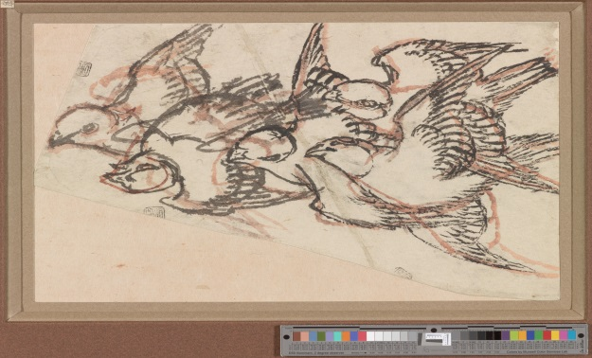

Katsushika Hokusai, Sparrows in Flight, 1830-40

The installation in the Pulitzer’s main gallery focuses on process, demonstrating the qualities of the ink and paper that were the artists’ tools and the exquisitely sensitive ways in which they were used. Four drawings here are sandwiched between glass: As the abundant natural light of the Pulitzer passes through the panes, it reveals the nature of the paper, including how exceptionally thin it is, and how artists sketched in and reworked their compositions. One of these drawings is Tsukioka Yoshitoshi’s (1839-1892) Interior Brawl (ca. 1874). Several areas of this exceptionally complex composition—which may challenge visitors as they try to deduce whose limbs are whose—exhibit a common method of making revisions, in which corrections were drawn on a separate piece of paper and pasted on top of the previous drawing.

Another compelling work in this gallery is an intensely taut and energetic image (late 19th century) of a warrior in motion. We can see how the unknown artist who created the drawing used various shades of ink to work out the form of the warrior’s robe and its relationship to his body as he turns. A drawing of The Lady of Eguchi as the Bodhisattva Fugen on an Elephant (late 19th century), also by an unknown artist, depicts a scene from a tale in which a prostitute is revealed as a manifestation of a Bodhisattva who travels by elephant. The boundary lines of this drawing, which is remarkable for its sweeping line, reveal that the design was intended to be rendered on a fan.

The final gallery on this level focuses on Utagawa Kuniyoshi (1798–1861), widely considered to be one of the most imaginative Japanese artists of the nineteenth century. Perhaps best known for his pictures of warriors, Kuniyoshi also frequently created works that would fulfill the popular desire for scenes deemed risqué, including images of kabuki theater—one of the most popular and raucous forms of entertainment among the commoner class, and an officially taboo subject. Kabuki actors like those depicted in Kuniyoshi’s Three Kabuki Actors (ca. 1850) were commonly recognized by their eyes and noses, and the paper corrections that Kuniyoshi pasted over the noses of two of the figures in this drawing show him working to ensure that they would be instantly recognizable.

Kuniyoshi was adept at avoiding censorship and other restrictions as he continued to supply audiences with images of their favorite subjects. The woodblock print Scribblings on the Storehouse Wall (1843-47), for example, presents caricatures of seven celebrated kabuki actors. The artist maintained, however, that he was not presenting new images, but merely copying graffiti that had been etched into the plaster of a storehouse wall. Although the figures here are rendered simply, with a limited number of pigments, they are nonetheless portrayals not only of the specific actors’ features but also of their mannerisms and gestures. With its sketch-like drawing and the artist’s signature scrawled in the lower register, this may be seen as a print version of a drawing, rather than the traditional obverse.
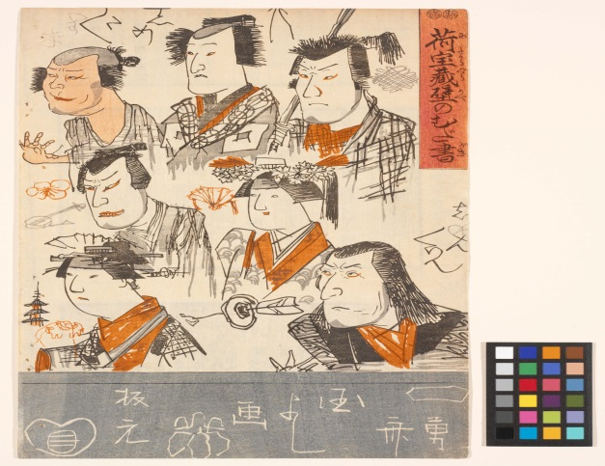
Utagawa Kuniyoshi, Scribblings on the Storehouse Wall (Kitakaragura kabe no mudagaki), 1843-47

The first gallery in the museum’s lower level is devoted to a single work, a black-and-white handscroll illustrating chapters ten and eleven of The Tale of Genji, the classic novel written by noblewoman Murasaki Shikibu in about 1000 CE. The scroll takes the form of hakubyō, drawings which were executed almost exclusively in monochrome and usually depicted court romances. Interspersing text and image, these were circulated among court women so they could develop their painting skill by copying the work. While official painting studios would have depicted the story with expensive materials and codified imagery, the hakubyō method did not require the services of a professional studio. Here, the artists themselves added visual interest through the admixture of a lacquering agent to the ink, creating a glossy sheen on the women’s long hair.

The main gallery on this level comprises about thirty drawings by Tsukioka Yoshitoshi, who was one of Kuniyoshi’s most gifted pupils, and best known for graphic portrayals of contemporary violence. (A particular kabuki actor requested on more than one occasion that Yoshitoshi paint the splattered blood that was to appear on the armor he would use on stage.) As we can see in works like Outdoor Fight Scene (1870s–80s), Yoshitoshi’s methods appear to be different from those of his teacher and other artists of earlier generations. Rather than defining his figures in outline, for example, he was concerned with the veracity of the human form, rendering skeletal forms in red (though the red would not appear in the print), and the clothing that covers the forms in black. The energetic movement and narrative incidents that mark this work—note the shoe that has flown off the foot of the man who has been kicked into the water—evoke a very particular and fleeting instant in time. Also seen here, Yoshitoshi employed foreshortening and vanishing-point perspective, which, although known to Japanese artists before this, achieved new popularity at this time through such commercially printed manuals as Hokusai’s Manga (on view later in the exhibition).

Yoshitoshi left behind a good deal of work, including both preparatory sketches and freehand drawings, and these provided a rich trove of material for others to study. On one side of this gallery three groups of drawings will be installed above a drafting table with benches, paper, and pens, intended to encourage visitors to try their own hand at drawing. Inviting visitors to study and draw, the Pulitzer hopes to foster close-looking and thereby a deeper engagement with a body of work that has historically been neglected. Other groups of work will include sketchbook pages that Yoshitoshi divided into quarters to accommodate multiple drawings, installed in pedestal cases to enable viewing in the round.
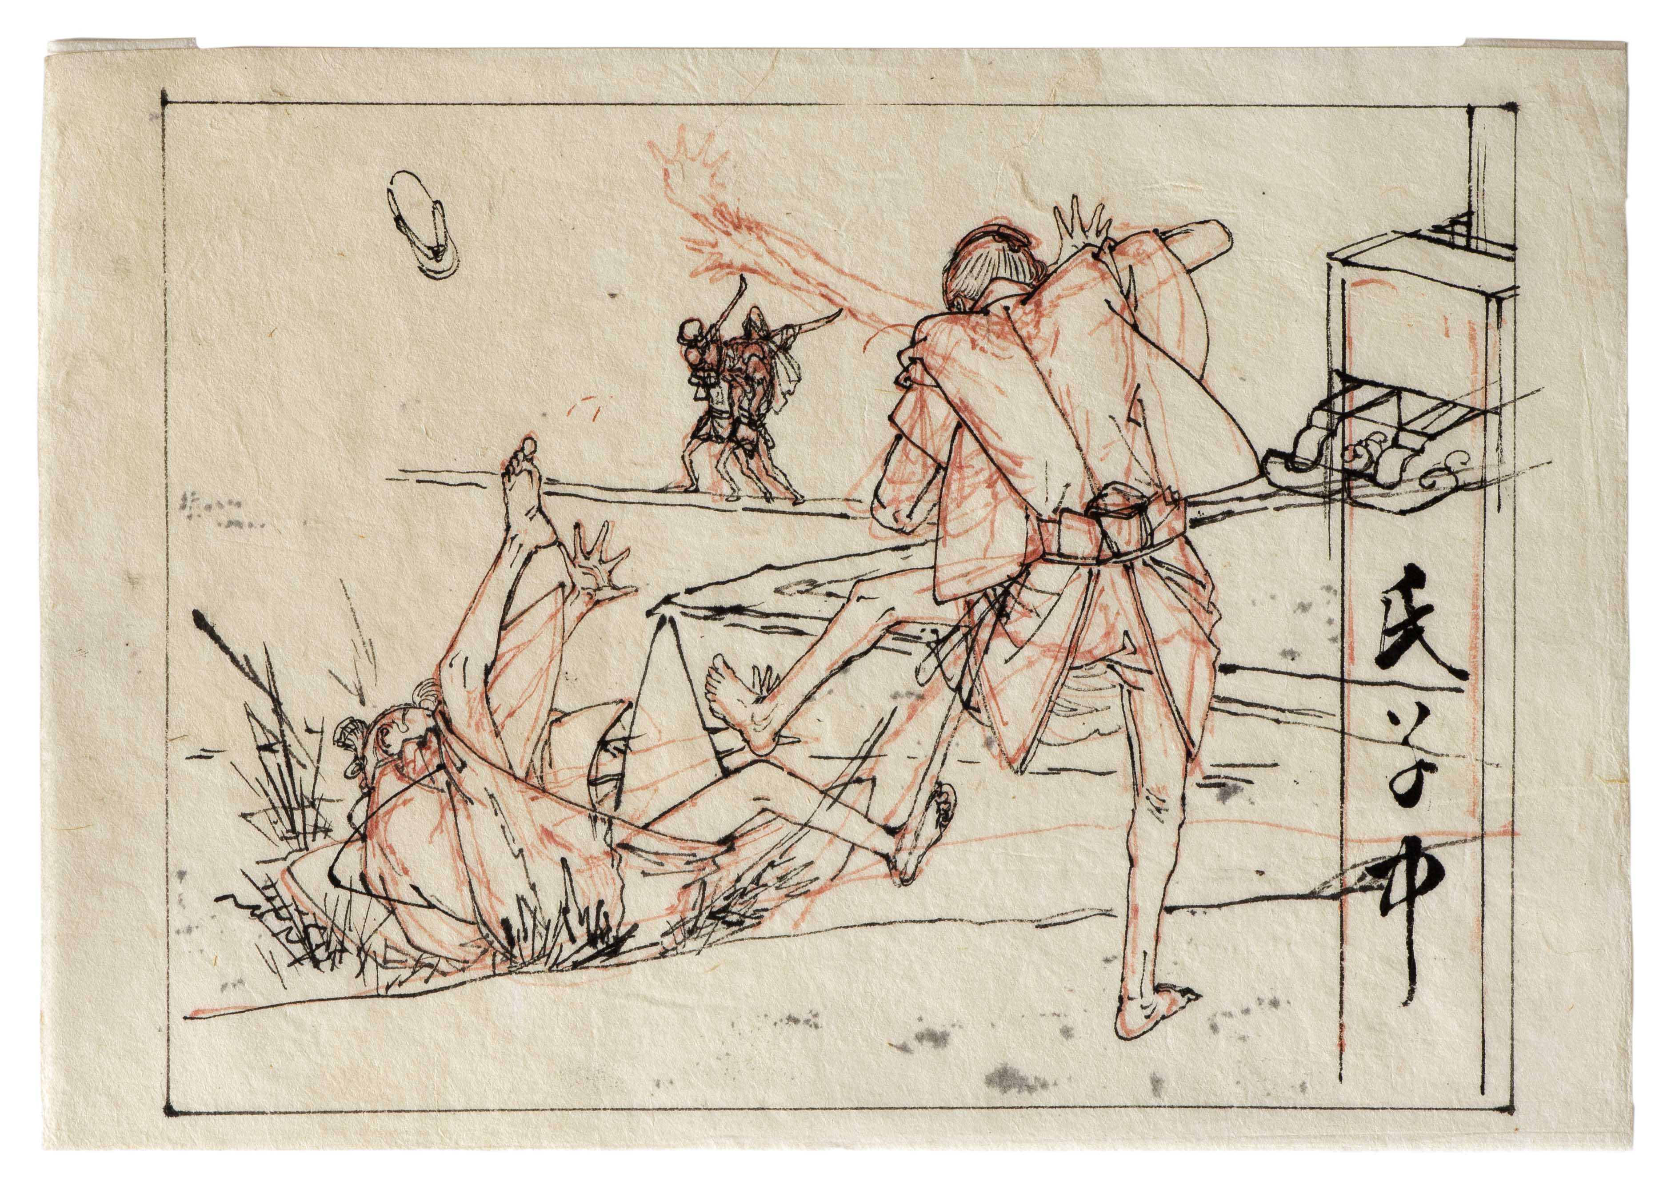
Tsukioka Yoshitoshi, Outdoor Fight Scene, 1870s-80s
In the exhibition’s final gallery, nine volumes of Hokusai’s fifteen-volume Manga, a collection of hundreds of sketches of various subjects, are on view. Published from 1815 to 1878, the Manga is one of the most enduring works of the Edo period. Although the pictures in it have long been enjoyed on their own merits, the artist’s preface makes it clear that this exhaustive compendium of his approaches to picture-making was intended as a guide for students hoping to imitate his style. Hugely successful, it led to unknown quantities of new work by amateur producers—and perhaps other professionals—who would have engaged with the manuals at different levels.

Living Proof will display two-page spreads from the Manga. These will include images such as a group of landscape elements—representing the subject of the highest status in East Asian painting—that a student would be expected to master before building a composite composition; drawings of plants, with detailed, annotated images of leaves and roots, that demonstrate the increasing attention to scientific observation that marked the era; and an encyclopedic variety of facial expressions.

Other displays in this gallery look at the relationships among the various figures—artists, carvers, printers, and publisher—who were responsible for producing woodblock prints. While there is not enough documentary evidence to develop a full understanding of how these various individuals interacted, through careful looking we are able to glean the variety of ways in which the process of creating a print unfolded. We see, for example, that there was significant flexibility in how much creative input each specialist exercised. Yoshitoshi’s Drawing for Hakamadare Yasusuke and Kidōmaru Battling with Magic (1887), for instance, contains only the most basic notation—Hakamadare’s armor is marked as “blue” at the top of the image, and Kidōmaru’s pants as “purple” in the bottom—leaving more refined details to the carver and printer. Yet the same artist’s Drawing for The Lady Ohyaku (ca. 1866) tells a different story, with its meticulous indications of how the patterning and pooling of blood were to be represented in the subsequent print.
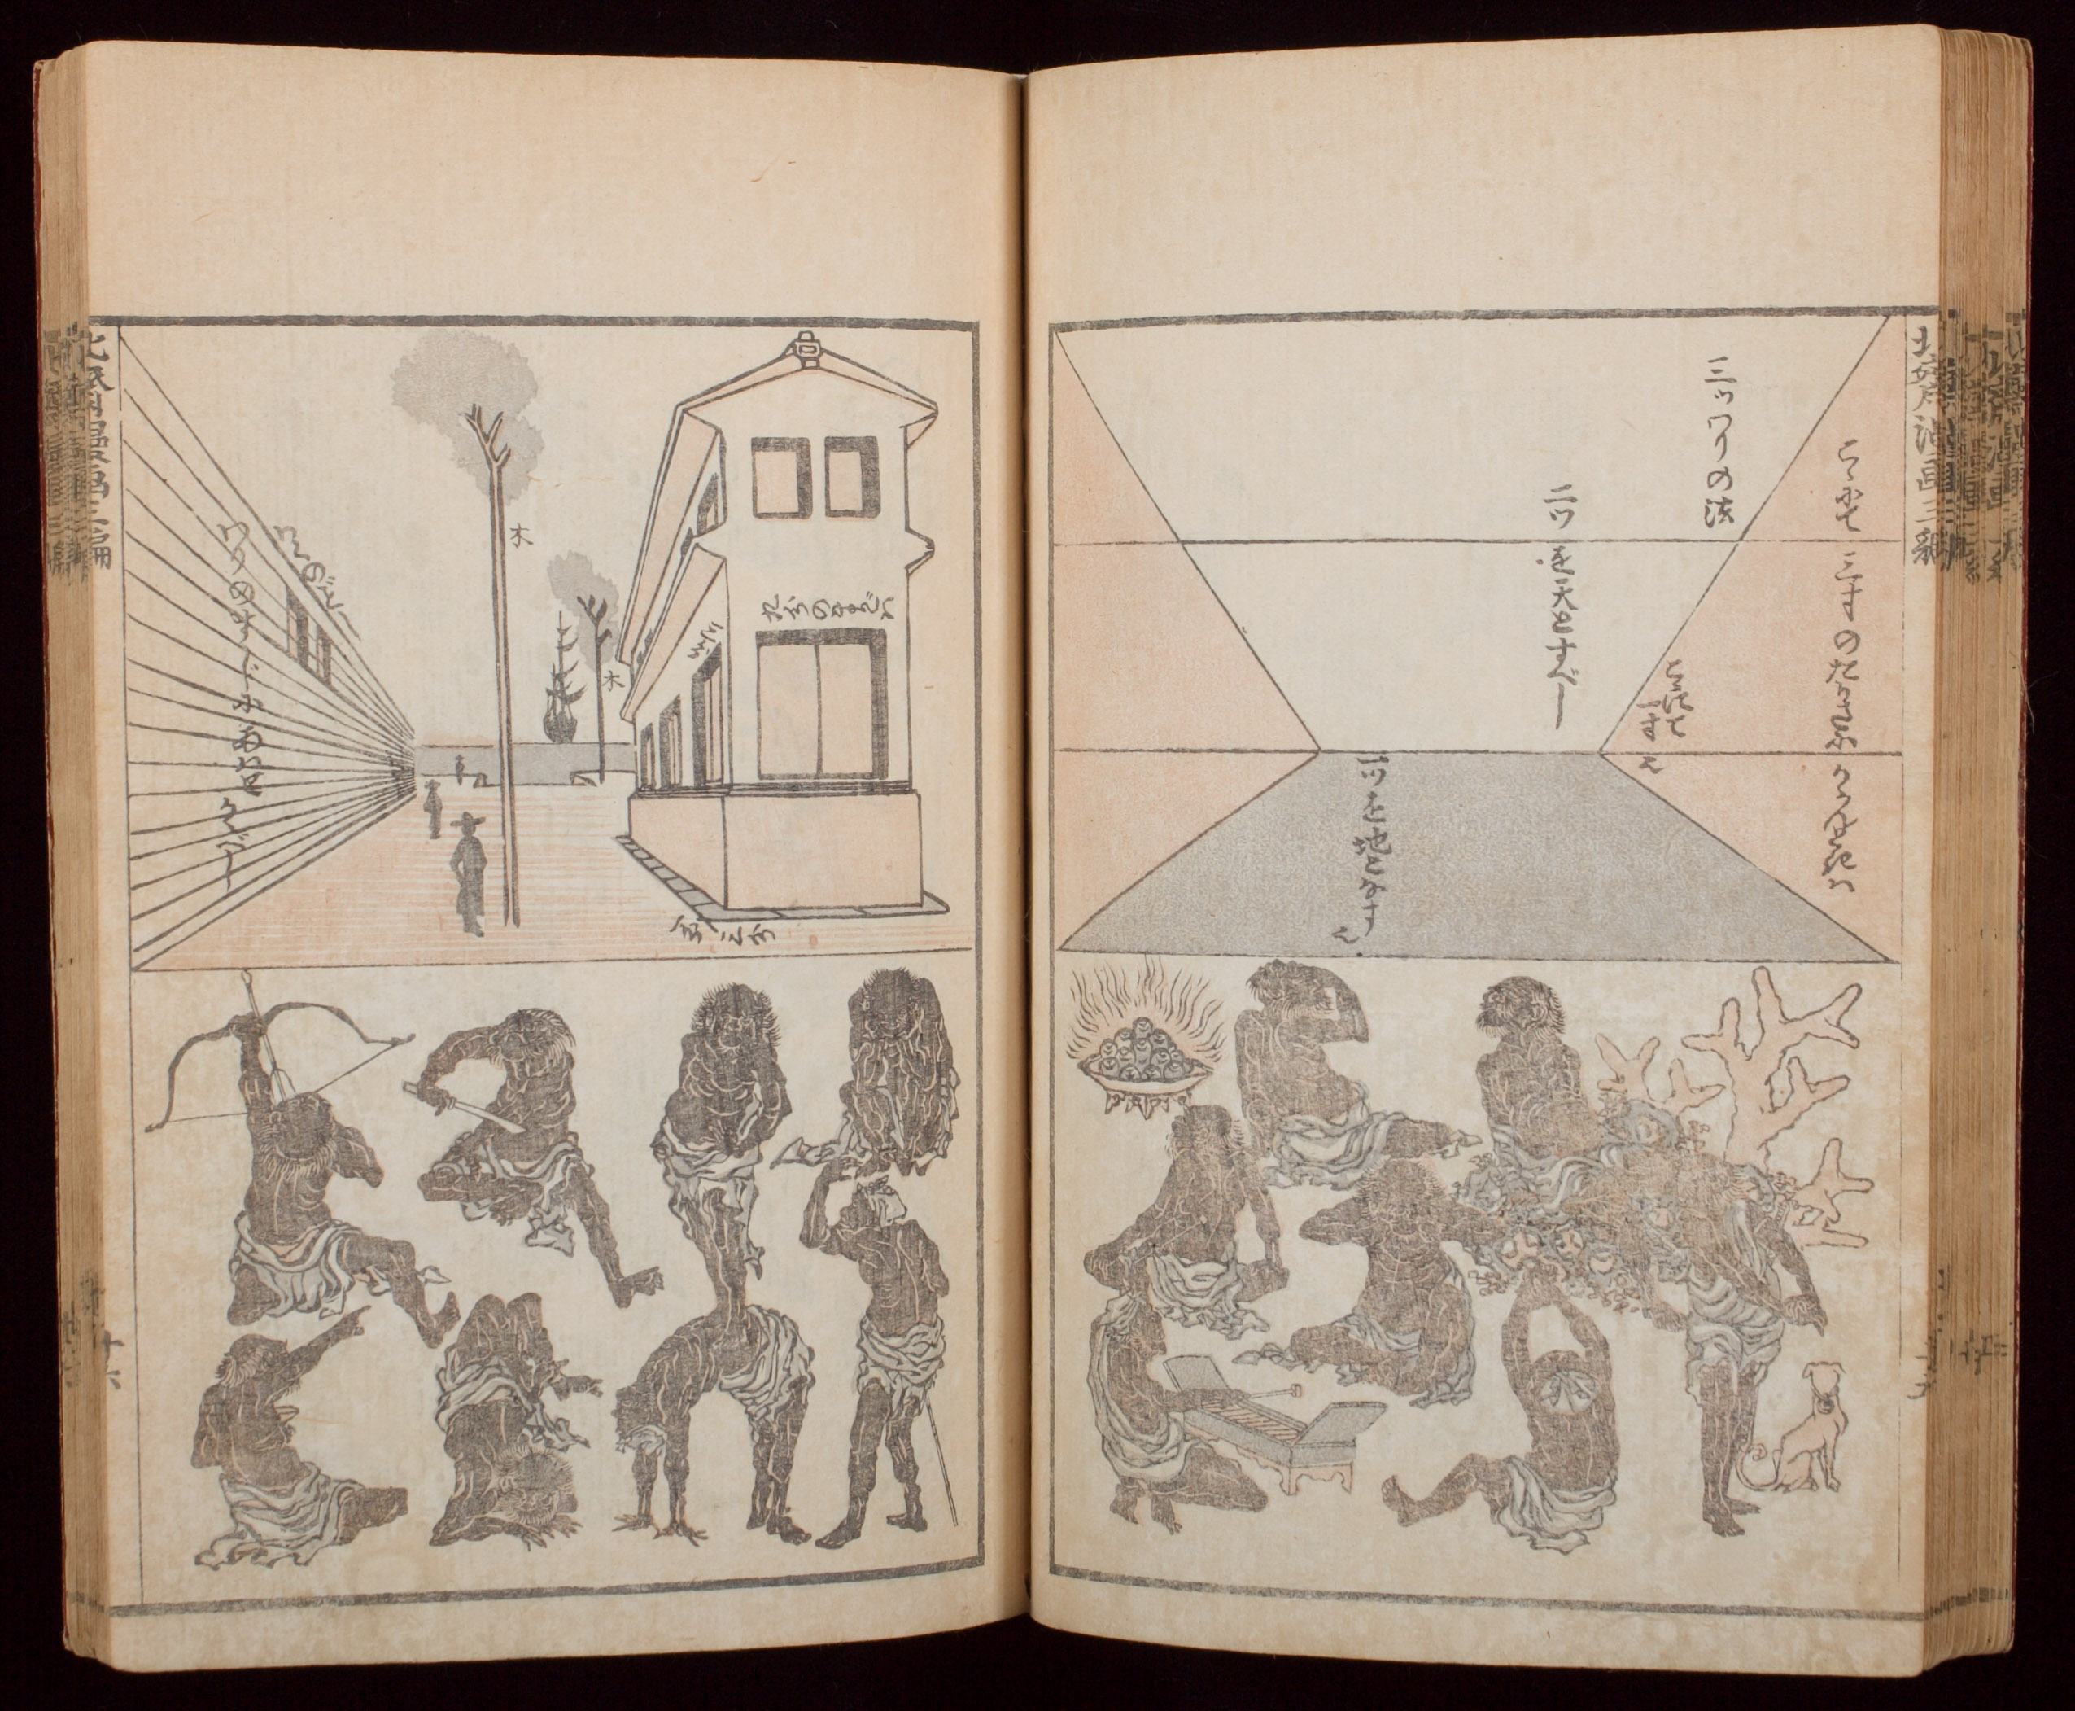
Katsuhika Hokusai, Hokusai Manga, vol. 3, 1815

In addition to their foundational role in the creation of woodblock prints, drawings may also have been destined for illustrated books, mostly light fiction that encompassed the same subjects as prints and kabuki plays. Some authors were also talented artists, as seen in a novel titled Illustrated Ghost Story of Konoshiro Tomobei, by comic author Shikitei Sanba (1766–1822). The exhibition pairs a version of the book with drawings by Sanba with one by Kuniyoshi that was issued over thirty years later, in which we can see how closely Kuniyoshi followed Sanba’s composition.

Companion Exhibition
Rough Cut: Independent Japanese Animation is a focused exhibition of three experimental short films created over the past century that highlight the relationship between drawing and animation. It will include works by Noburō Ōfuji (1900–61), Yoji Kuri (b. 1928), and Maya Yonesho (b. 1965). Produced outside of mainstream commercial studios, the films will highlight compelling innovations from early silent film to contemporary experimentation with collage and stop-motion.

About the Pulitzer Arts Foundation
The Pulitzer Arts Foundation believes in the power of direct experiences with art. The museum presents historic and contemporary art in dynamic interplay with its celebrated Tadao Ando building, offering unexpected experiences and inspiring new perspectives. Valuing close looking and civic engagement, the Pulitzer is a place for contemplation and exchange that brings art and people together.

Located in the Grand Center Arts District in St. Louis, Missouri, the Pulitzer is free and open to the public between 10am–5pm on Wednesday through Saturday, with evening hours until 8pm on Friday. For more information, visit pulitzerarts.org or call 314-754-1850.

###

Media Contacts
National:
Lucy O’Brien: lucyobrien.comm@gmail.com | 646-590-9267
Stephanie Markovic: smarkovic.comm@gmail.com | 347-628-4688

St. Louis:
Katie Hasler Peissig: khasler@pulitzerarts.org | 314-754-1850 ext. 235

image captions

P. 1
Utagawa Kuniyoshi
Study of Two Actors, 1830s-50s
Ink on paper
12 ¼ x 9 inches (31.1 x 22.9 cm)
Collection of Susan Lorence
Photo by Jim Corbett

P. 2
Utagawa Kuniyoshi
Three Kabuki Actors, ca. 1850
Ink on paper
15 3/16 x 10 ¾ inches (38.6 x 27.3 cm)
Lluïsa Sàrries and Peter Freeman, New York

P. 3
Katsushika Hokusai
Sparrows in Flight, 1830–40
Ink and color on paper
5 7/8 x 9 inches (15 x 23 cm)
Collection of Stephen Flavin

P. 4
Utagawa Kuniyoshi
Ibaya Sensaburō, publisher
Scribblings on the Storehouse Wall (Nitakaragura kabe no mudagaki), 1843-47
Polychrome woodblock print; ink and color on paper
Image: 14 1/16 x 9 5/8 inches (35.7 x 24.5 cm)
Gift of Roger S. Keyes and Elizabeth Coombs
Museum of Art, Rhode Island School of Design, Providence
Photography by Erik Gould, courtesy of the Museum of Art, Rhode Island School of Design, Providence

P.5
Tsukioka Yoshitoshi
Outdoor Fight Scene, 1870s–80s
Ink and color on paper
6 7/8 x 9 ¾ inches (17.5 x 24.8 cm)
Collection of Jack Shear
Photo by Jim Corbett

Katsushika Hokusai
Hokusai Manga, vol. 3, 1815
Woodblock-printed book; ink and color on paper
Closed: 8 15/16 x 6 1/4 x 9/16 inches (22.7 x 15.8 x 1.5 cm)
Harvard Art Museums/ Arthur M. Sackler Museum, Gift of Mrs. Henry Osborn Taylor
1928.15.57
Imaging Department © President and Fellows of Harvard College

